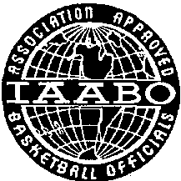
Western Massachusetts District Board #31
Approved Basketball Officials
IAABO

2022 APPLICATION FOR MEMBERSHIP
I hereby acknowledge that I am 18 years of age and submit this application for membership to the International Association of Approved Basketball Officials and Western Massachusetts District Board #31.
I request the opportunity to take the written rules examination. It is my understanding that if I pass the written examination with a grade of 86% or higher, I will then be eligible to pass a floor examination/training classes. The application fee of $250.00 is payable in full prior to the first clinic with this application & includes clinic fees, test fees, 1st year dues, rule book, and administrative fees. No refund of the application fee will be given.

Please fill out the information below

NAME:____________________________________ PHONE #:_____________________________

ADDRESS:______________________________________________________________________________

CITY:_________________________________ STATE:__________ ZIP CODE:________________________

E-MAIL ADDRESS: ___________________________________________________________________________

APPLICANT SIGNATURE: ____________________________________________________________________

Please return this form along with a check or money order made payable to

Western Mass Board of Approved Basketball Officials
c/o Jeffrey Rivet
180 Beauchamp Terrace #14
Chicopee MA 01020

Please note: All classes will take place at the South End Community Center, 99 Marble Street, Springfield MA 01105
Classes start at 7:00 PM until approximately 9:00PM
Class Dates: September 28, October 5, October 12, October 19, October 26, November 2nd
Examination Date: November 7th 6:30 PM

